**INFO 5505 – APPLIED MACHINE LEARNING FOR DATA SCIETISTS**

**Assignment -4**

**Data:**

The data set contains descriptive attributes of digitalized images of a process known as, fine needle aspirate (FNA) of breast mass.

We have total of 29 features that were computed for each cell nucleus with an ID number and the diagnosis (Malignant, Benign)

The objective of this assignment is to develop a Random Forest model that can predict the diagnosis of new patient image features.

1. **Data Loading**

The data is loaded into a data frame and verified using pandas library as shown below.

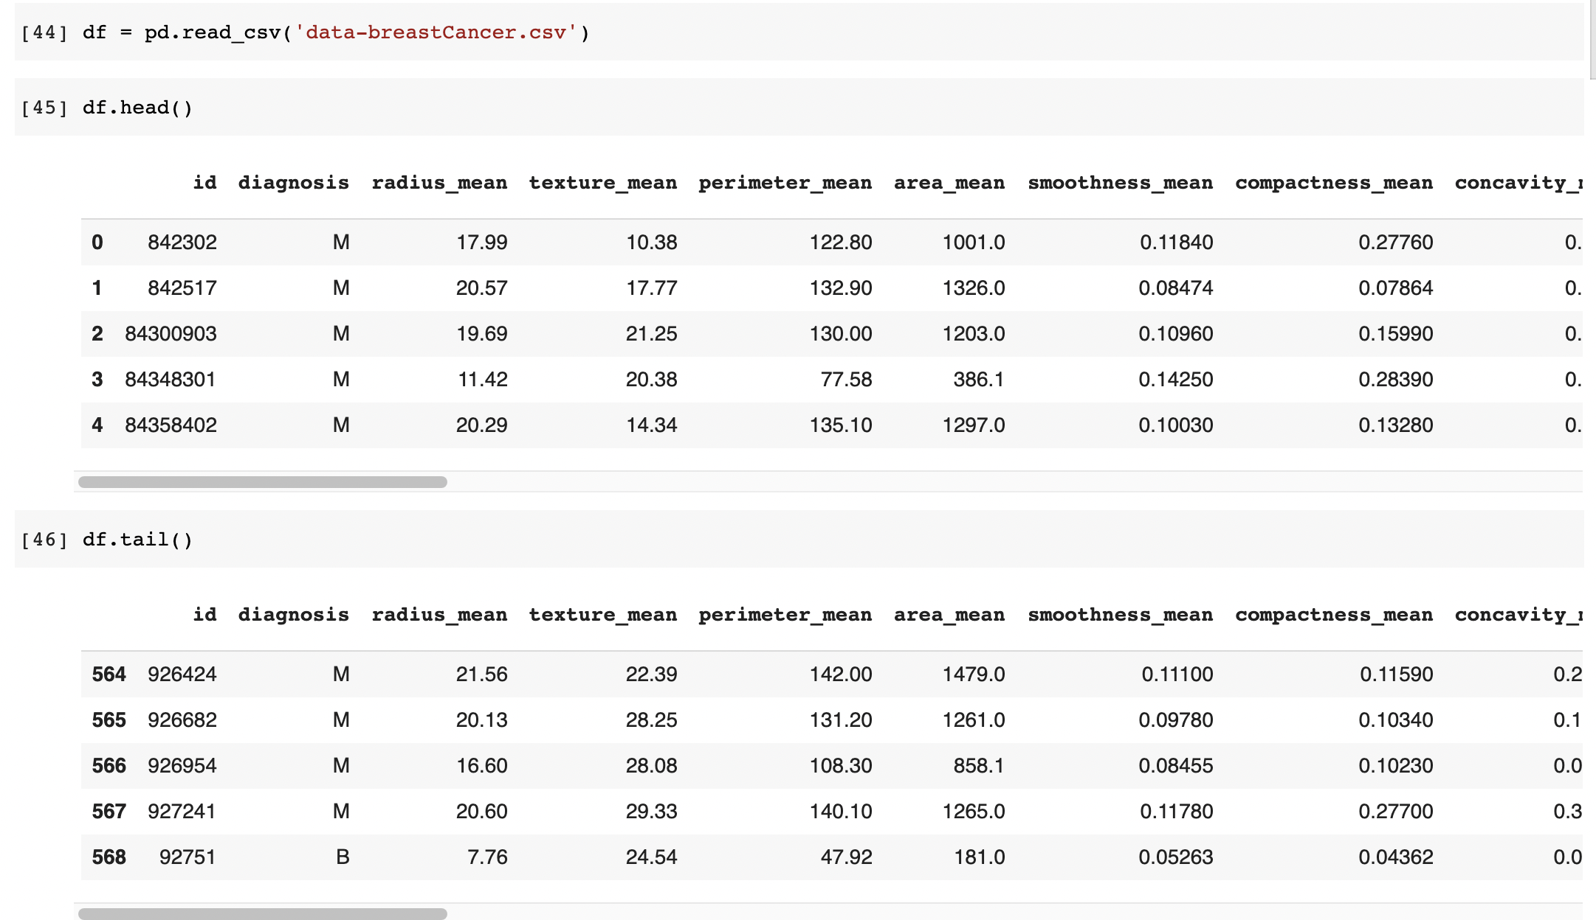

Getting the information of the data set such as data type of each feature

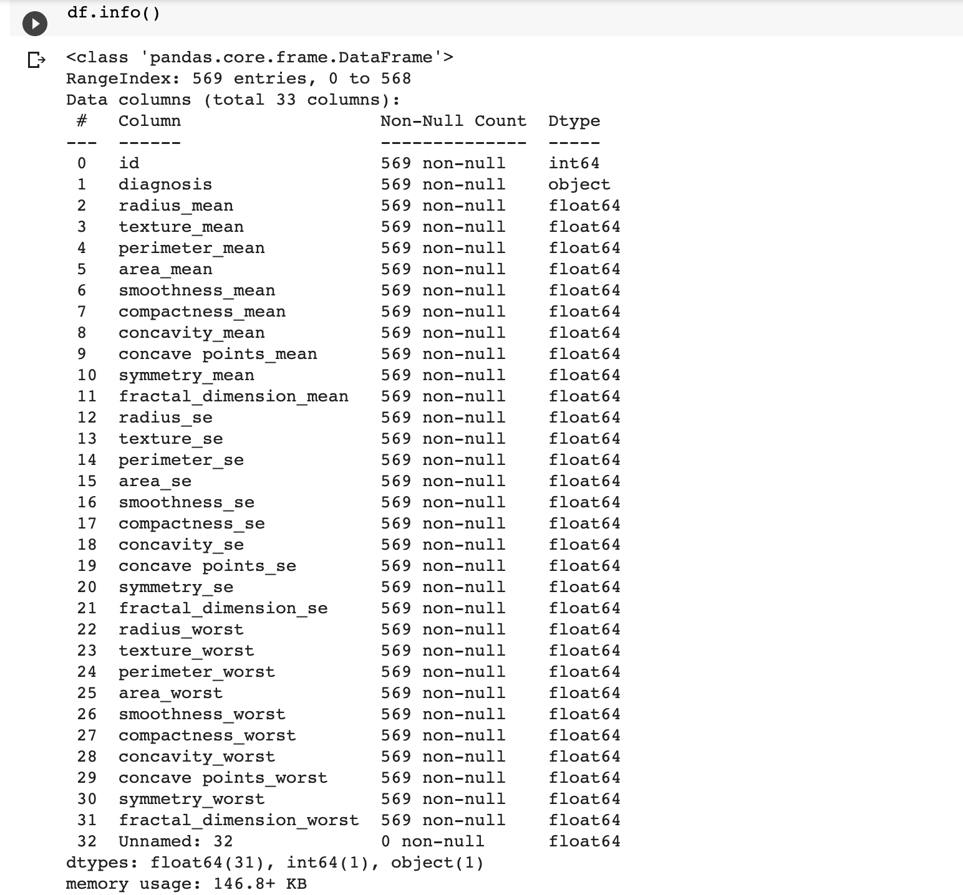

1. **Some descriptive statistics of the data**

Using the describe function of pandas I have displayed some descriptive statistics of the given data as shown below.

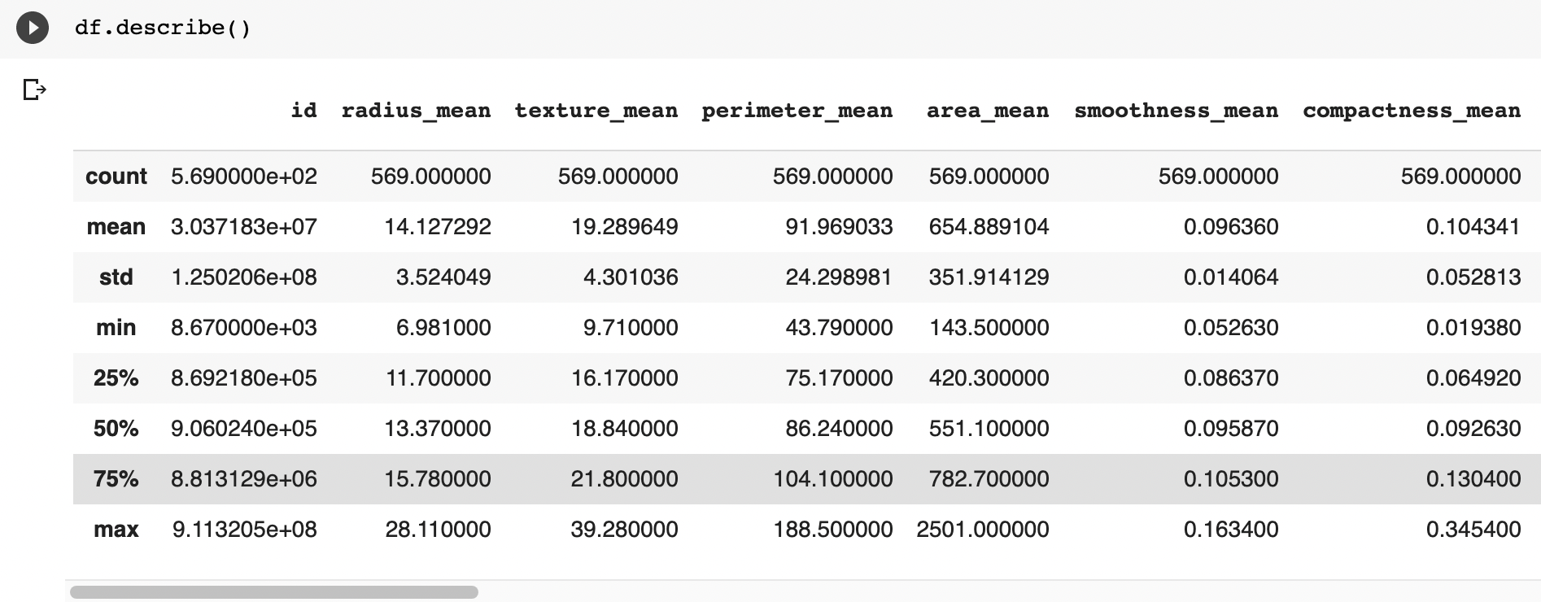

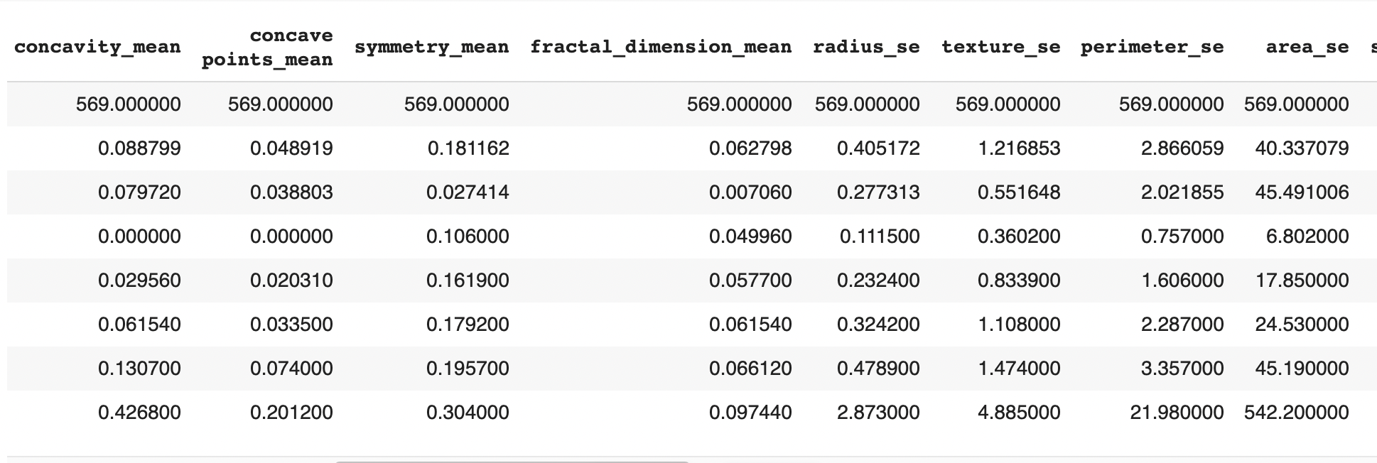

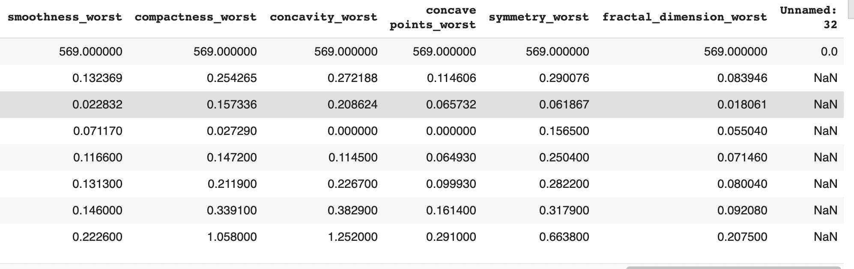

Standardization is an important requirement for many classification models that should be handled when implementing pre-processing. Some models (like [neural networks](https://www.datascience.com/resources/webinars/introduction-to-neural-nets-with-the-data-incubator)) can perform poorly if pre-processing isn't considered, so the describe() function is a good indicator for standardization. Fortunately, random forest does not require any pre-processing.

1. **Feature Engineering**

As we observed the data set there are some features whose names have extra spaces in between and there is an unnamed column in the data set which is not useful for further analysis. We need to convert the diagnosis variable from nominal to binary.

Below code removes the extra spaces and replace them with underscore, Sets id variable as the index column and removes unnamed column from the data set.



Converting the diagnosis variable into binary format.



1. **Finding missing values**

Missing values are found in the data set using missingno plot of pandas as shown below

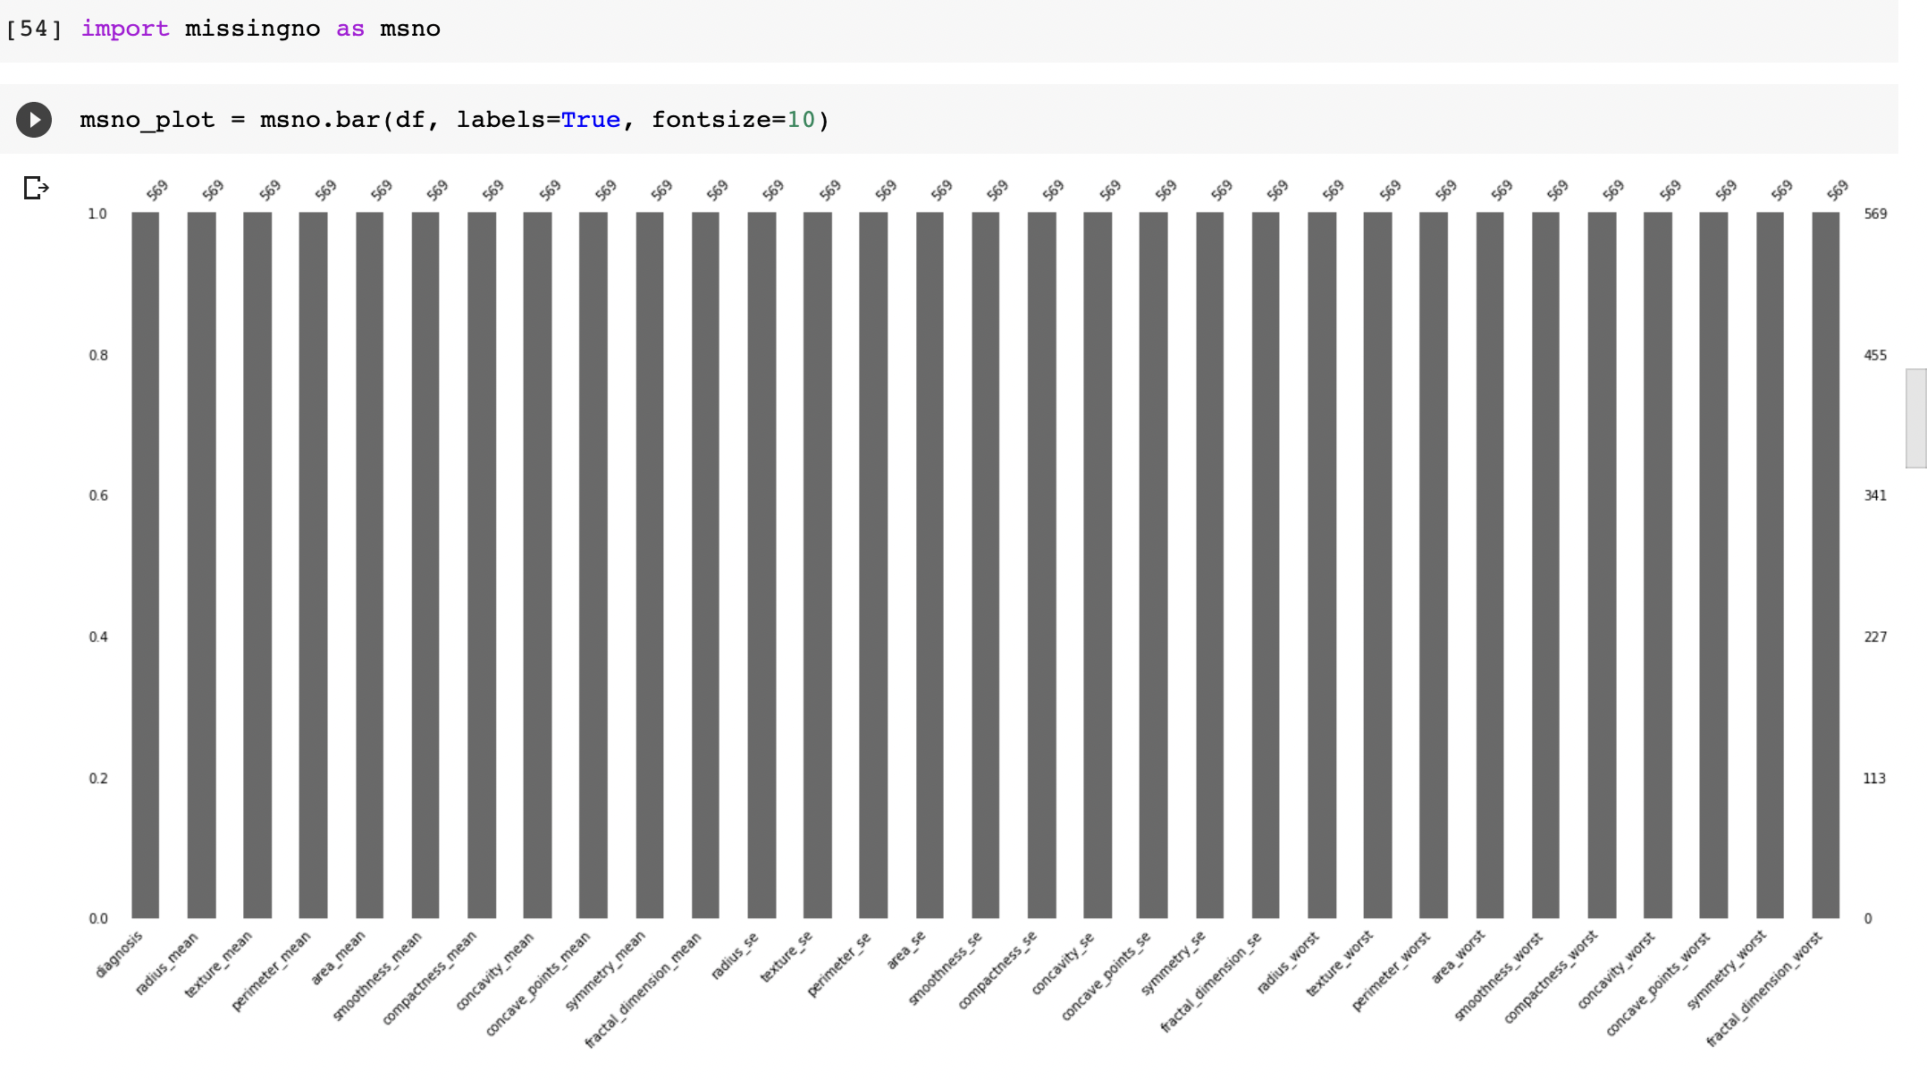

As we can see the above visualization, we can see that all the bars are full. So, there are no missing values in the data set.

1. **Class Imbalance**

When observations of one class outnumber the observations in another class of a target variable then we can say that there is a class imbalance in the data set. Class imbalance is a common problem in machine learning, especially in classification problems. Imbalance data can hamper the model accuracy big time.

In our data set to check the class imbalance I have used the count plot. By using the count plot we can see the count of observations in each class of the diagnosis variable.

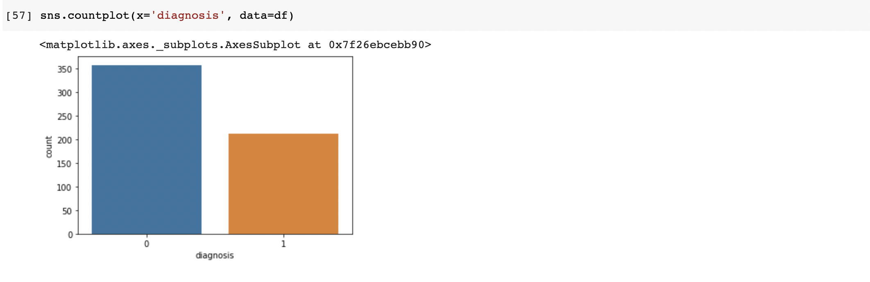

From the above count plot, we can see that the number of observations in class 0 is 350 and the number of observations in class 1 is 208. So, both the classes are distributed in 1:2 ratio approximately.

As per the industry standards this ratio is acceptable. From this we can say that there is no class imbalance in the data set.

1. **Splitting the data set into training and test sets**

The given data set is split into 80% training set and 20% test set as shown below.



We will use the training set to train the model and perform some optimization. You will use the test set, which will act as unseen data, to assess model performance.

When using this method for machine learning, we need to be wary of utilizing test set to create models. Data leakage is a common problem that can result in overfitting.

1. **Fitting a Random forest model**
2. **Bagging the variables**

Bagging is an ensemble algorithm that fits multiple models on different subsets of a training dataset, then combines the predictions from all models. Random forest is an extension of bagging that also randomly selects subsets of features used in each data sample. Both bagging and random forests have proven effective on a wide range of different predictive modeling problems.

Although effective, they are not suited to classification problems with a skewed class distribution. Nevertheless, many modifications to the algorithms have been proposed that adapt their behavior and make them better suited to a severe class imbalance.

In this project I have implemented the bagging by using the bagging classifier of sklearn and validated the classifier using K fold cross validation

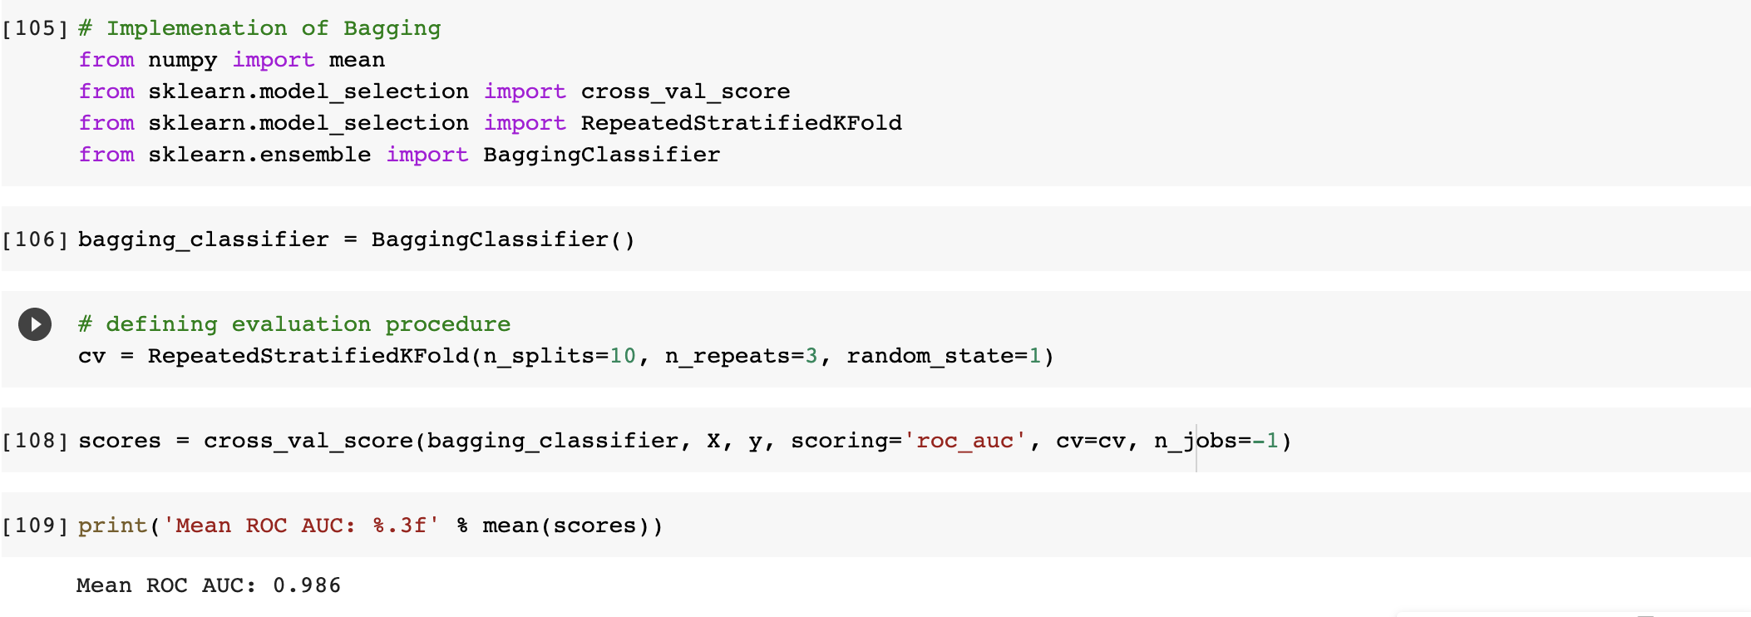

From the above result we can see that the bagging classifier has an accuracy of 0.986 (98.6%)

1. **Hyper tuning Parameters and finding best parameter values**

Before fitting a rf model we need to tune the parameters to get the best model. Below parameters are tuned in this project.

1. max_depth
2. max_features
3. criterion

Before tuning the parameters, the below values are passed to the random forest classifier and got the best parameters using best_params of GridSearchCV from the sklearn.

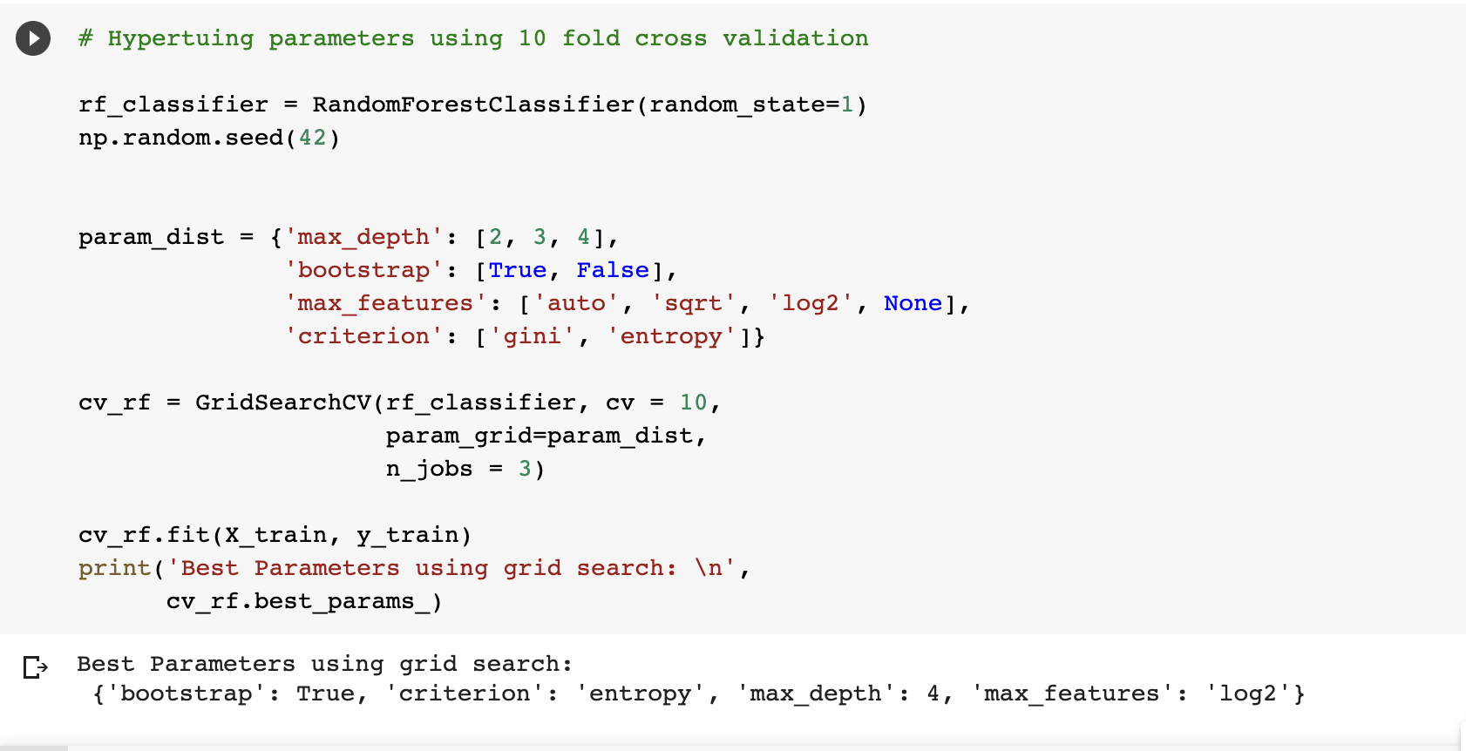

From the above result we can see that the best parameter values are max_depth =3, max_features=auto, criteria = gini, and max_features = log2

1. **Developing final model using best parameter values**

Finally, the random forest model is fit by setting the parameter values after tuning.

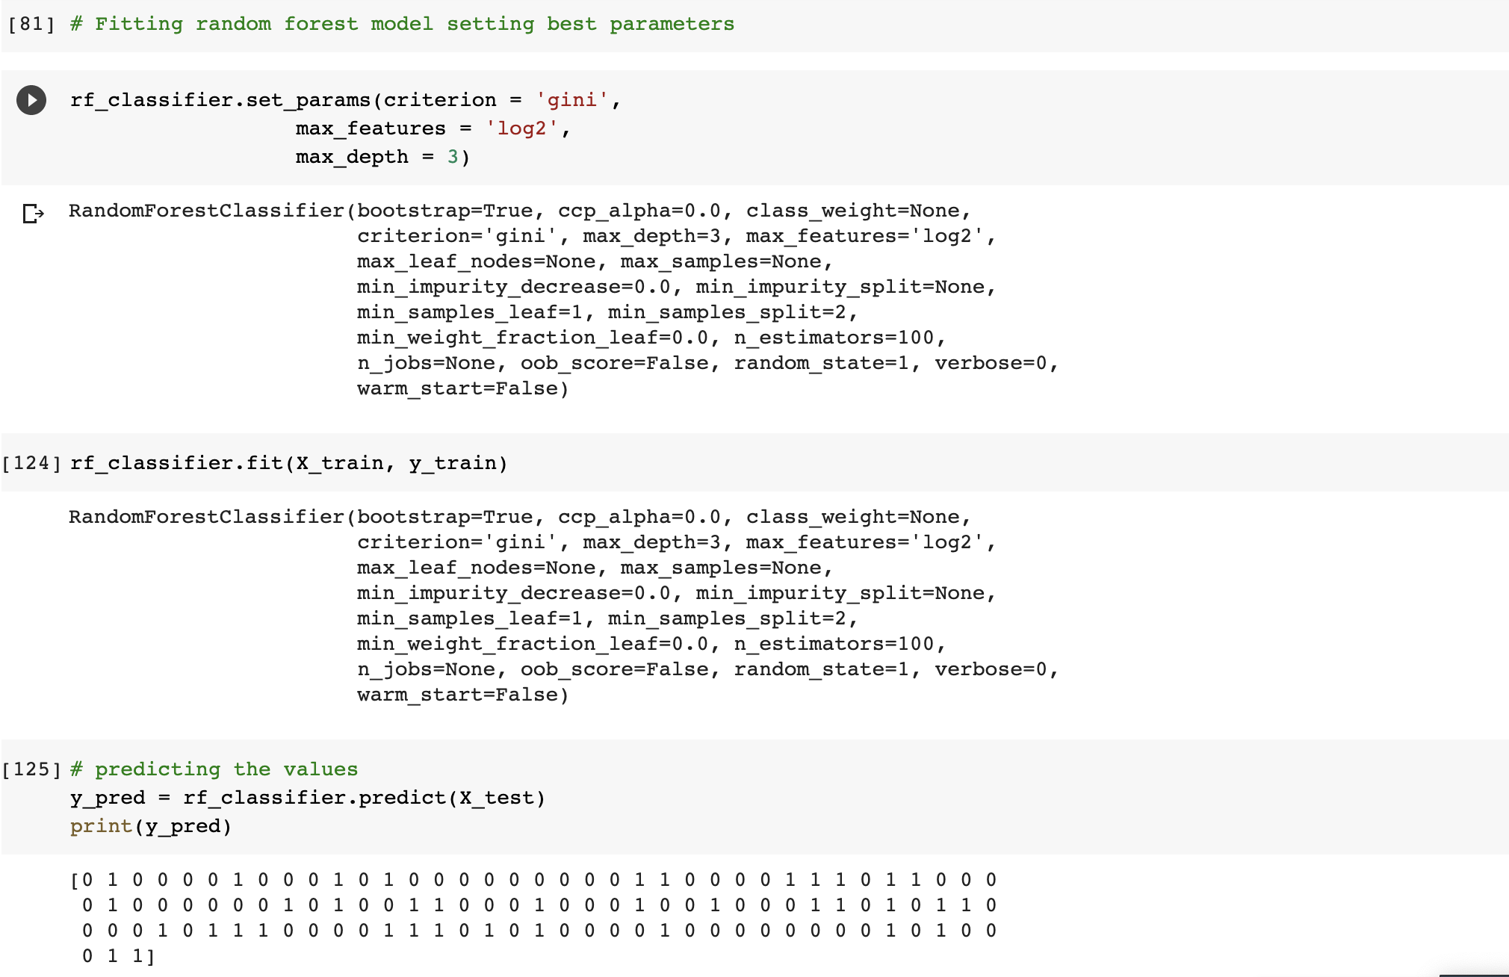

1. **Feature Importance**

Feature importance is an essential criterion for a random forest model development. Once we have trained the model, we can assess variable importance. One downside to using ensemble methods with decision trees is that you lose the interpretability a single tree gives. A single tree can outline for us important node splits, as well as variables that were important at each split.

By using the best parameters found before the importance of the features identified as follows.

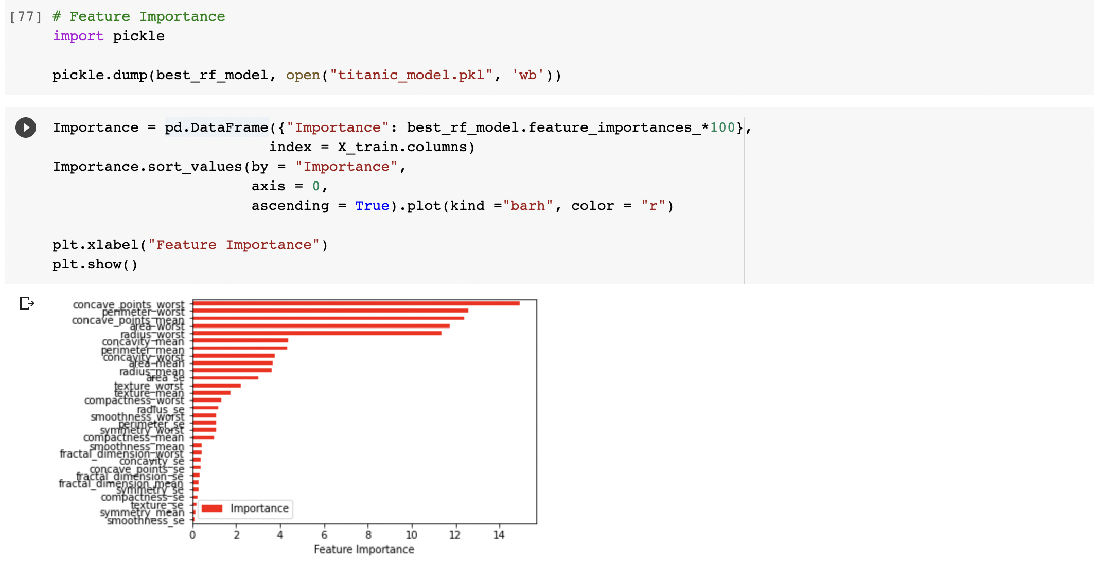

1. **Confusion Matrix**

The confusion matrix is created using seaborn visualization.

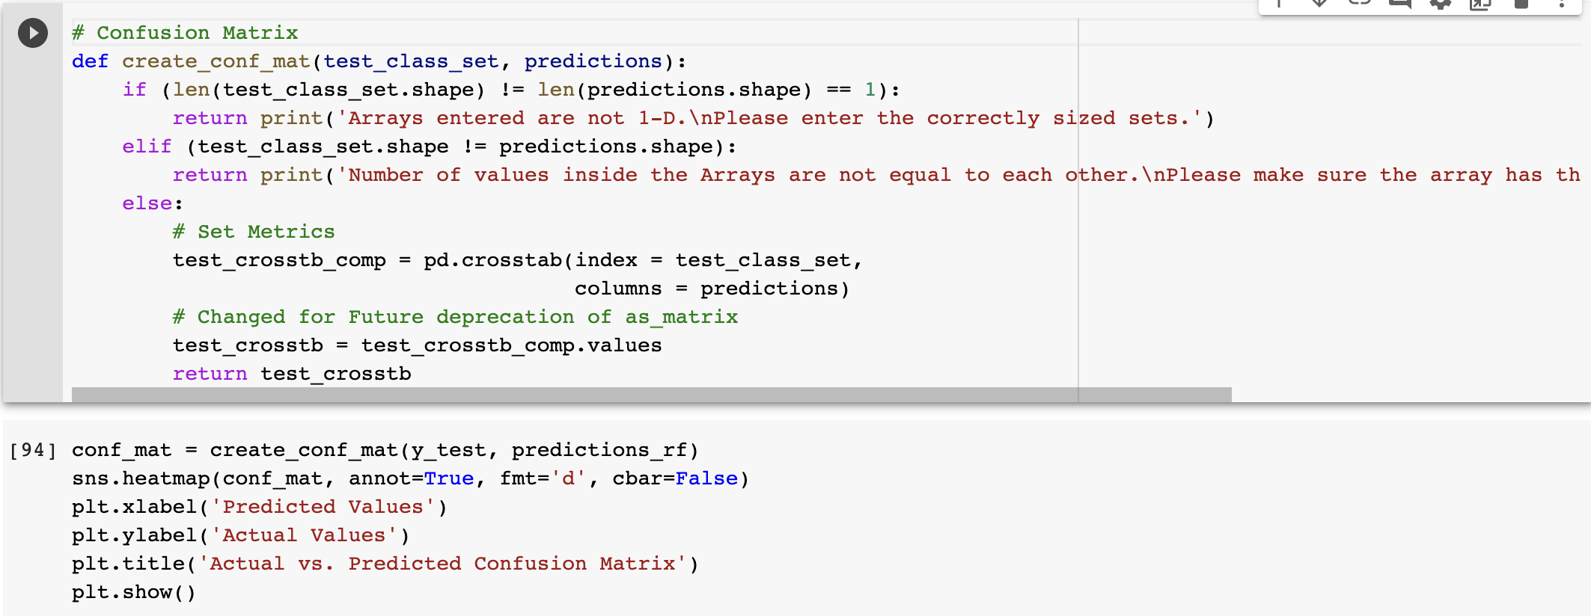

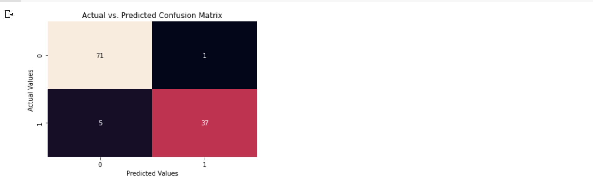

From the above confusion matrix below results can be inferred

In the test data set actually there are total 114 patient records among which 72 are actual 0s and 42 are actual 1s

The random forest model we developed has predicted 1 record as 1s from out of 72 0s and 5 records as 0s out of 42 1s.

1. **ROC curve**

A receiver operating characteristic (ROC) curve calculates the false positive rates and true positive rates across different thresholds

If an ROC curve is located in the top left corner of the plot, that indicates an ideal model i.e., a false positive rate of 0 and true positive rate of 1. On the other hand, a ROC curve that is at 45 degrees is indicative of a model that is essentially randomly guessing.

Predicting the probabilities of each withheld test data point being in either class

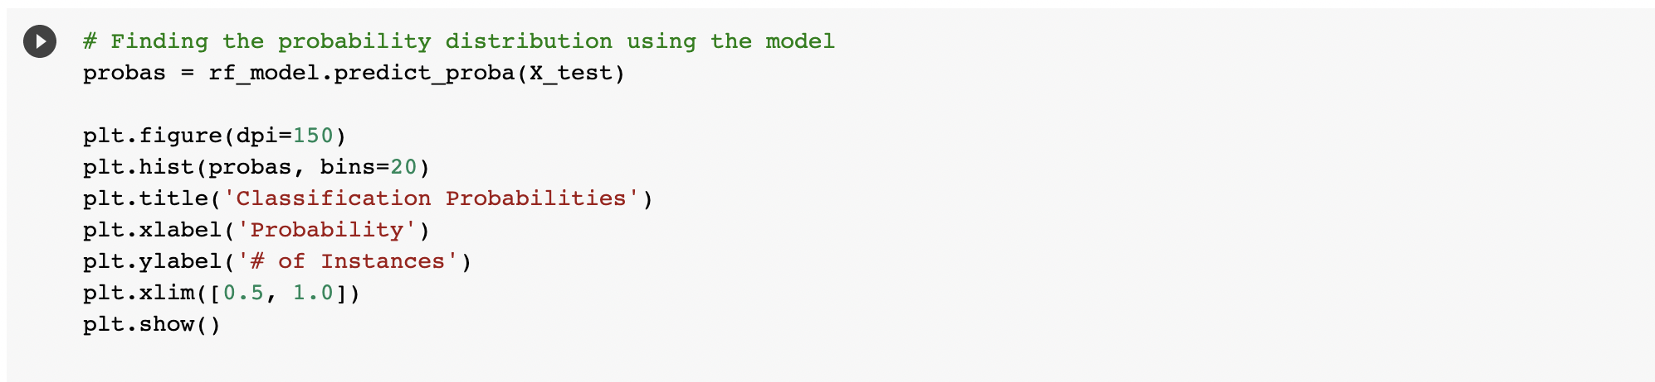

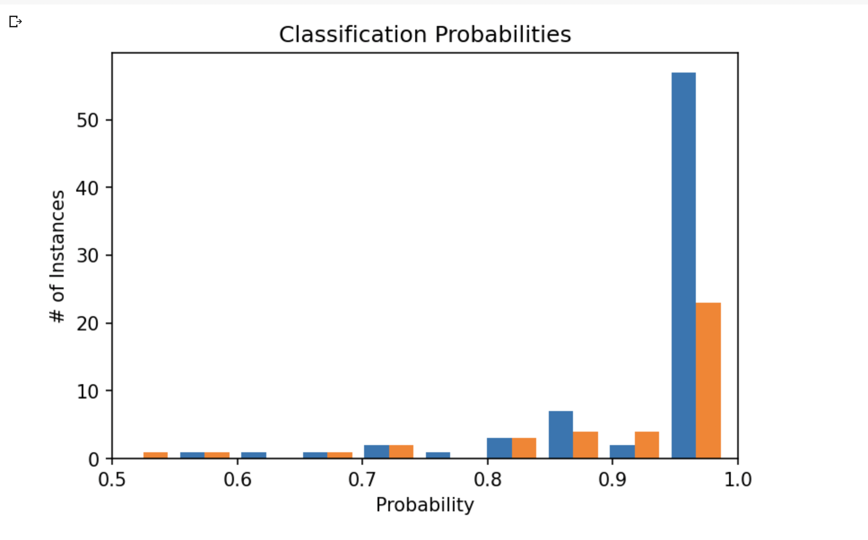

Drawing an ROC curve using these probability distributions

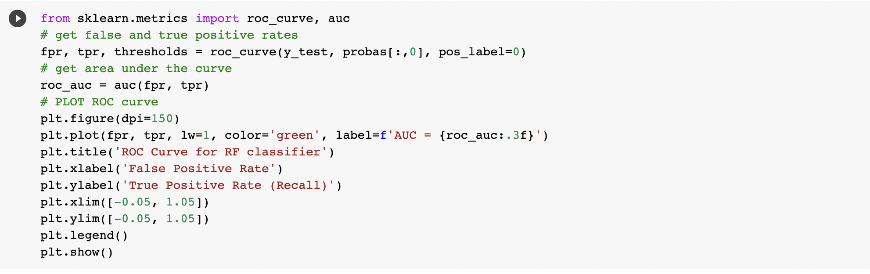

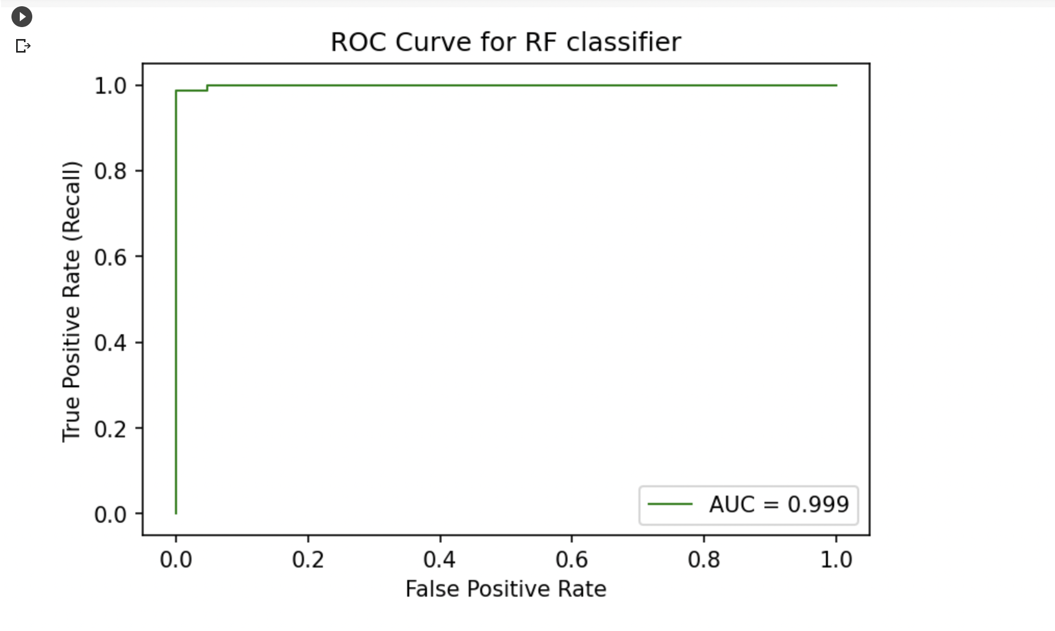

From the above ROC curve, we can see that the accuracy of the model is 0.99%. That means our model is pretty good one.